**Ideation Phase – Empathize & Discover**

**Date:** 30 june 2025

**Team members: Yuvraj singh, Amrutansh Panda**

**Project Name:** SocialeX

**Maximum Marks:** 4 Marks

**Empathy Map Canvas**

*Understand the needs, frustrations, and behaviors of social messaging app users who want secure, personal, and rich communication experiences through SocialeX.*

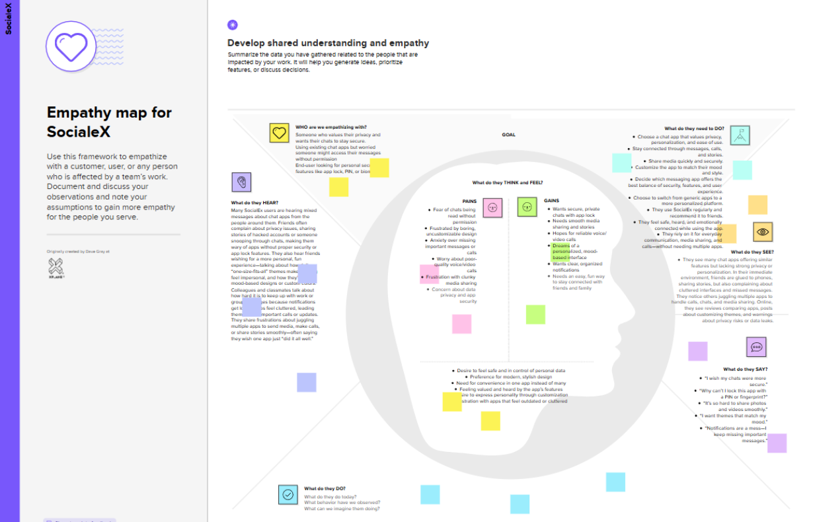

https://app.mural.co/t/thinkyuvraj0402/m/thinkyuvraj0402/1751906194630/254da7c88e0284daa636ea0ec97f4a66d55ebbe8?sender=u0962b0c76755179c68819427